Speaking Proposal
Love Racing and Autism
Eric D. Zimmerman
Founder and Technical Director The Buddy Project
Autism Self Advocate
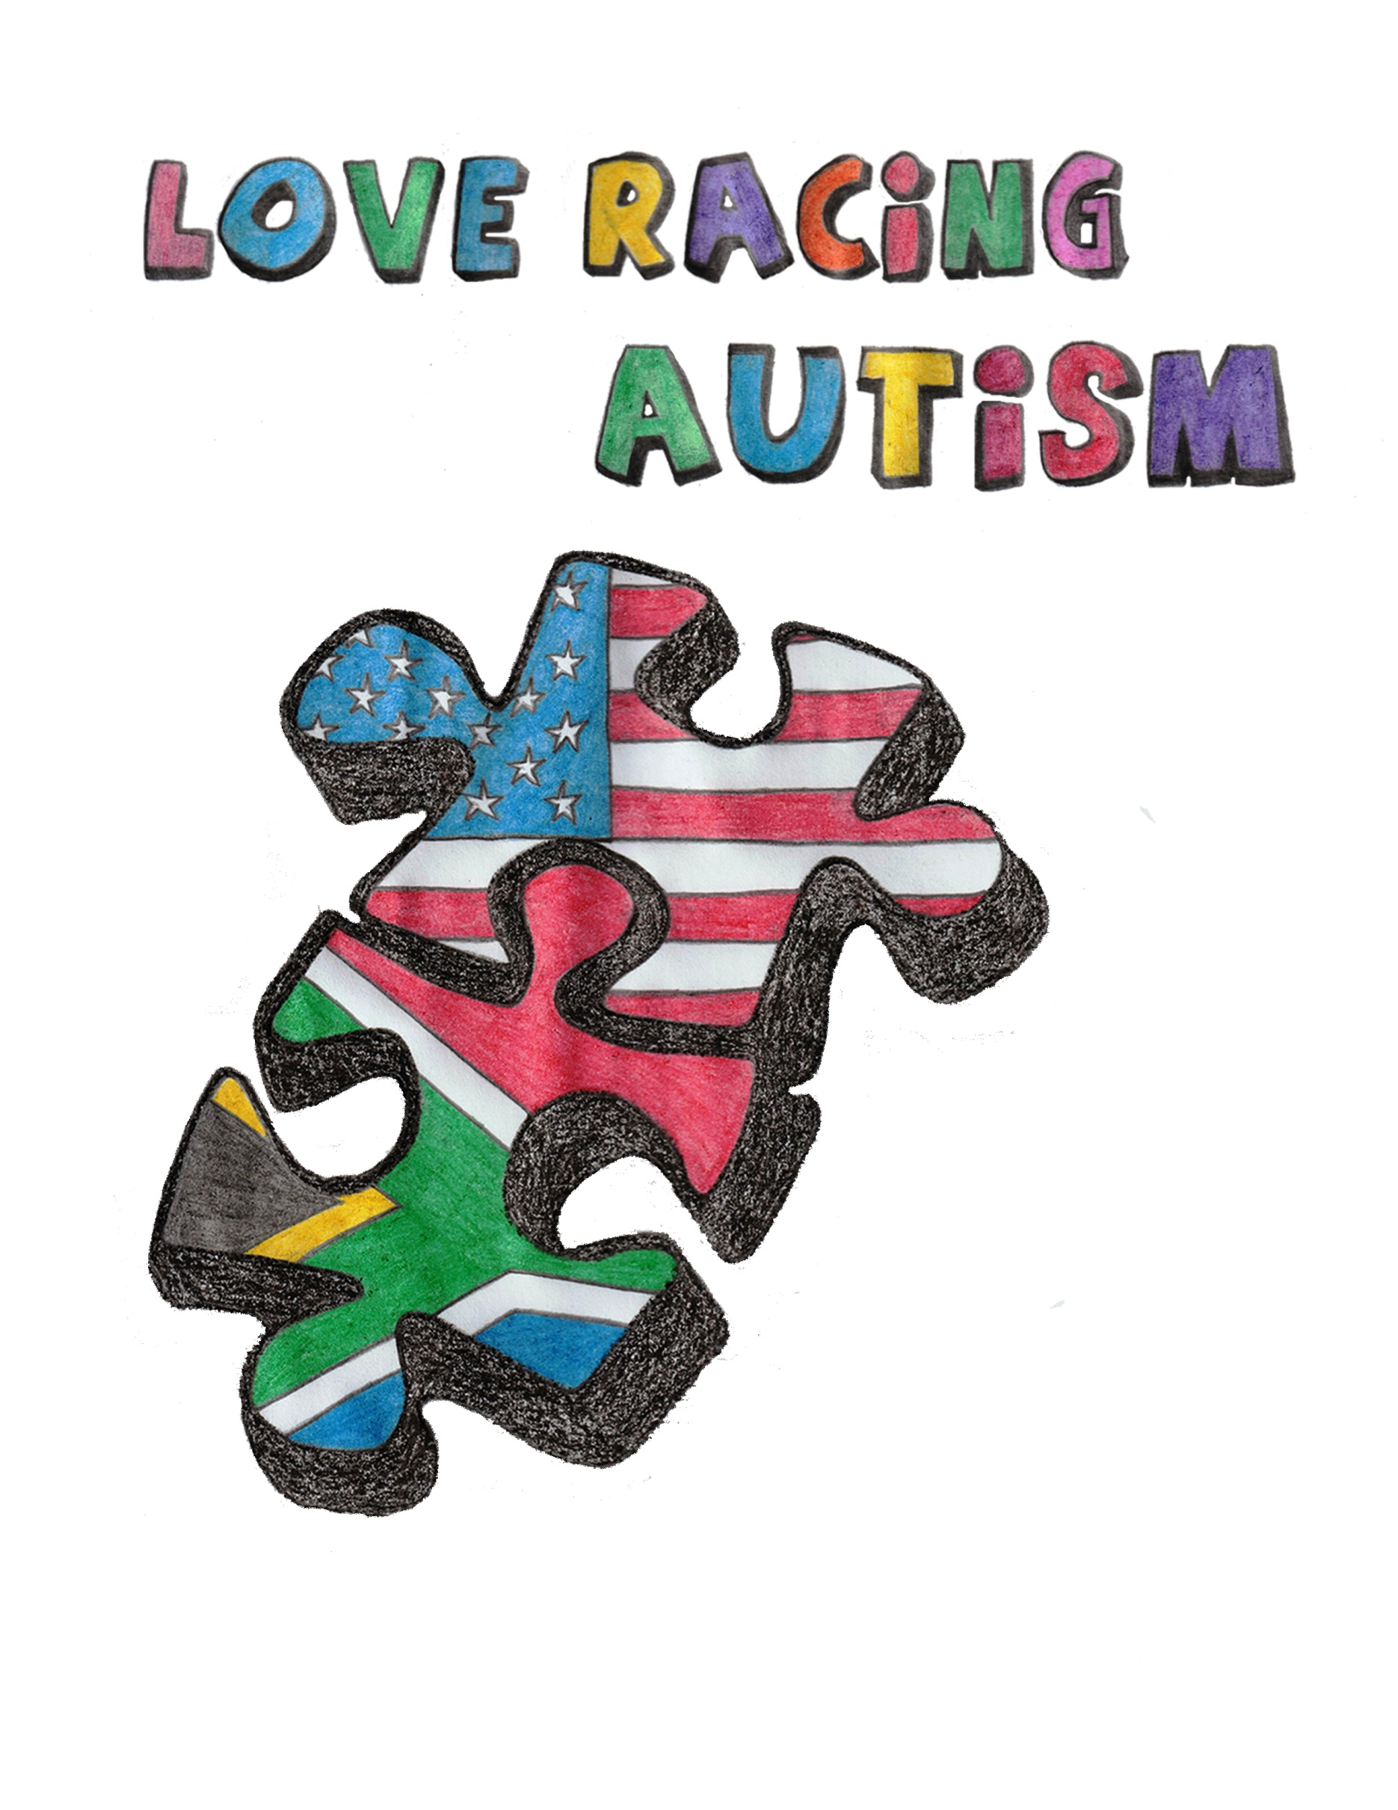

Eric would love to speak at one of your upcoming 2020 Parent Support Groups or conference(s) your group puts on. We can work with you as we have a scholarship program that was awarded some funds to cover ALL costs.
Parents will want to hear Eric D. Zimmerman speak, because he inspires and shows that there is hope in every child, and a Autism Diagnosis is not the end of the world. Eric has been speaking since 2015 across the United States and South Africa and has written two eBooks so far "Anything But Ordinary" and "Dare to be Different" his 3rd book titled "Love Racing and Autism" will be out early 2020. The 2020 “Love Racing and Autism” speaking presentation goes along with the book.
In 2020 will come Eric D. Zimmerman’s 3rd book. This book is called “Love Racing and Autism” and highlights how he found his wife after a long search and a lot of heartbreak, and how he realized his dream of racing through the help of a few friends. These two stories intertwine at about the same time and the book gives you a very deep look into Eric’s experiences from a first person point of view. The speaking event will give inspiration to the parents and even kids on the spectrum of what they can become with hard work and dedication by seeing what work Eric has put into The Buddy Project programs and his personal goals. They can see that is possible to be like others and have a family with their disability. Eric met his wife Gertina Zimmerman, and the story is one like no other. The Speaking presentation lasts about 1 and a half Hours, with the following 30 Minutes for questions, with a total of 2 Hours. We are currently scheduling for our 2020 tour, which will kick off in March 2020 In Jackson, Michigan.
Scholarships and Financial Assistance for groups that cannot afford the presentation fee:
In the Summer and Early Fall 2019, a Local Art Shop, called The Muse in Frederick, MD held an Art Auction where local artist purchased canvases, and painted a painting based off of the inspiration of “Planting the Seed of dreams”. The auction raised $7400.00 to help assist Autism Parent Support groups who cannot afford the costs to have Eric at their event due to financial constraints. When the canvasses were sold to the artists, they wrote their dreams on a small piece of paper and then Whitney, Owner of The Muse, paired them with seeds of trees to be planted after the art auction.
Below is a Quote for Newspaper from a press release about the final numbers of the Lend a Hand Event from Eric D. Zimmerman:
“The Money raised from the Lend A Hand Art Auction supporting The Buddy Project, will allow us to provide more presentations to low income, and low budget Autism Parent support groups about my personal journey of growing up on the high end of the Autism Spectrum. This disability is referred often as the “Invisible disability” because if you see a person with it in public it is not always obvious to those unfamiliar. Adults can simply come off as rude or creepy, and children can appear as if they are spoiled or there parents are not being good parents when they the kids have meltdowns in public. Both sides of the spectrum lead to high rates of divorce in these families as they interrupt the marriage and family dynamic. These funds are a blessing to allow us to take our “Love, Racing, and Autism” speaking tour on the road in 2020. The free speaking tour will touch how I grew up with challenges, coped with them, and started The Buddy Project to help many with disabilities. It then goes into how I met my best friend and my wife Ina. There are only a small percentage of people with autism in romantic relationships and even smaller amount of those who are married”
About Eric D. Zimmerman:​
Eric D. Zimmerman is Founder and Technical Director of The Buddy Project, and should know about technology’s ability to unlock some of the everyday barriers faced by the special-needs community: The 31 year-old has Asperger’s syndrome, a form of Autism which hinders social interaction.

From working with Best Buddies International, he grew to recognize that, unlike him, many of the disabled have little to no access to such commonplace household technologies as even their own email account.

Zimmerman, a graduate of Frederick High School, decided to take action. Officially, since 2007, his technological savviness (certified in computer repair and rehabilitation by the Career Technology Center’s IT program), united with his caring, altruistic drive to help others, has been brightening lives. That’s when, out of his Frederick home, he began The Buddy Project. And, ever since, his not-for-profit organization has acted upon its mission of providing free computers (and/or other technologies) to qualifying IDD candidates. It’s also a mission that the Frederick County Commission on Disabilities has duly honored by bestowing Zimmerman with its Distinguished Service Award. He also serves on the Board of Directors of Service Coordination, Inc. the largest provider in Maryland of targeted case management for people with developmental disabilities.

Used computers, received through donation, are the starting point for The Buddy Project’s initiative. Every device gets completely refurbished back to new. But since not intended to be used by the whole family, each computer is custom-tailored to meet the specific individual needs of its intended recipient.
​
Eric is a volunteer at Meritus Medical Center in Hagerstown, MD where he contributes to the Clinical Engineering Department.
​
Eric also is a Stock Car Driver, Currently racing 4 CYL Stock Cars at Trail-Way Speedway in Hanover, Pennsylvania.

Eric’s Speaking Resume (Significant Events):
South by Southwest Austin, TX 2019. “Why We Need Autism Tech, like Yesterday”
Chattanooga Autism Center General Conference 2019, Chattanooga, TN
Chattanooga Autism Center: Southeast USA Center for Adult Autism Symposium July 2019
“Anything but Ordinary” Presentation at Wharton School of Business- University of Philadelphia, Philadelphia, Pennsylvania- March 2015
“Anything but Ordinary” Presentation at UC Davis, Davis California November 2015
AASCEND National Conference, San Francisco California October 2016

A Few Quotes from Groups Eric has visited:

Blogs and Articles:
PLEASE VISIT ERICDZIMMERMAN.COM

Professional Memberships:
Founding Fellow, American College of Healthcare Trustees

Director, Board of Directors
Service Coordination, Inc.
Frederick, MD
2014-Present

